S.A.F.E. TOOL
Strategic Assessment of
Firearm Enforcement

PURPOSE OF this TOOL
The S.A.F.E. Tool is an inventory of questions designed to facilitate a discussion with a survivor on safety strategies around firearms. This Tool will assist survivors with evaluating if, when, how, and for what period they may want to request that an intimate partner who abused them be prohibited from use, possession, or ownership of firearm(s) and ammunition. The information obtained from this Tool can assist survivors when creating a comprehensive personalized plan to improve their safety and the safety of their child(ren) by allowing them to incorporate their strategies around firearms. This Tool is not a lethality assessment tool nor should it be used as one.

WHO SHOULD USE THIS TOOL?
The S.A.F.E. Tool is designed for survivors and the attorney or advocate who assists them in preparing a comprehensive safety plan that includes firearm safety and, if they so choose, a petition for a protection order that requests removal of these weapons from their abuser. The attorney or advocate working with the survivor should be knowledgeable in the areas of intimate partner violence and the state firearms laws of their jurisdiction. This Tool is not intended for use by system advocates, prosecutors, law enforcement professionals or any other professional who may assist survivors.

HOW TO USE THIS TOOL
This Tool consists of an inventory of questions divided into seven categories and a photographic guide of commonly possessed firearms. Please review each section in order. Each section is pertinent in helping the survivor make informed choices around firearm safety. It is recommended that the attorney or advocate working with survivors use this Tool in conjunction with the Firearm Checklist for Advocates. This Checklist can provide guidance on the federal domestic violence firearm prohibitions and how to remove weapons from prohibited persons.

Important Message for Survivors
Safety planning is an ongoing process. This Tool should be revisited as necessary when revising your safety plan. If you change your mind after reviewing this Tool and no longer want the firearms removed or want to discuss safety strategies related to firearms that remain within the ownership, possession, or access of your abuser, please contact your community advocacy organization. If you need help locating a legal service or advocacy organization, please contact the National Domestic Violence Hotline at www.thehotline.org; 1-800-799-7233; 1-800-787-3224 (TTY).

This project was supported by Grant No. 2014-TA-AX-K046 awarded by the Office on Violence Against Women, U.S. Department of Justice. Points of view in this document are those of the National Center on Protection Orders and Full Faith and Credit and do not necessarily represent the official position or policies of the U.S. Department of Justice.

IMPORTANT CONFIDENTIALITY CONSIDERATIONS FOR
SURIVIORS AND THE ADVOCATES THAT ASSIST THEM
Federal law has established safeguards to protect the confidentiality of survivors of domestic violence, dating violence, sexual assault, or stalking. Shelters, rape crisis centers, domestic violence programs or similar victim service programs that receive funding through the Violence Against Women Act (VAWA) or the Family Violence Prevention Services Act (FVPSA) may not disclose any identifying information about the survivor, the survivor’s location, or the services the survivor received from their program without the informed, written, reasonably time-limited consent of the survivor. Even if a program is not receiving federal funding, many states have confidentiality laws or domestic violence victim/advocate privilege statutes that limit the information an advocate may disclose regarding a conversation with someone who seeks or received services from their organization.

Advocates have an obligation to advise survivors of the laws that protect a victim’s right to confidentiality. When discussing this information, advocates should also inform the survivor of the different roles community advocates and system advocates play in assisting, as well as the limits in confidentiality and/or privilege communication protections. This information will assist the survivor in making an informed decision prior to sharing confidential information. For more information on federal confidentiality requirements and strategies to protect the privacy of your clients, please visit the National Network to End Domestic Violence’s confidentiality resource at nnedv.org/policy/issues/vawaconfidentiality.html; and the Battered Women’s Justice Project’s Confidentiality: An Advocate’s Guide at www.bwjp.org/resource-center/resource-results/confidentiality-an-advocate-s-guide.html

TECHNICAL ASSISTANCE IS AVAILABLE:
The S.A.F.E. Tool was developed by the National Center on Protection Orders and Full Faith & Credit to assist survivors and the attorneys and advocates who help them devise safety strategies around firearms. For technical assistance on the use of this Tool or issues related to the issuance, service, or enforcement of protection orders or the removal of firearms, please contact us at 800-903-0111, prompt 2, or email us at ncffc@bwjp.org.

S.A.F.E. TOOL INVENTORY OF QUESTIONS
The following inventory of questions is divided into seven sections. Each section is devised to facilitate a discussion and analysis of the risk and benefits of having firearms removed from an intimate partner. Please review each section in order unless otherwise directed to another section.

Section A: Ownership, Possession, or Access to Firearms
This section will assist you with identifying pertinent information on your partner’s ownership, possession, or access to firearms.

1. | Does your partner own, possess, or have easy access to firearms? (If no, please continue to Section B)  If yes, how long has your partner owned/possessed/had access to firearms? | Yes No
2. | Did you or a family member purchase, transfer, or give any of the firearms to your partner?  If yes, is the firearm registered in your partner’s name? If not, who owns the firearm? | Yes No  Yes No
3. | Does your partner have any firearm licenses/permits?  If so, which? | Yes No
4. | Does your partner maintain or use a firearm for protection, employment, or as a hobby (recreation)?  If yes, which? | Yes No
5. | If your partner uses a firearm for employment is he/she employed by the military, or a local, state, or federal law enforcement or government agency that requires him/her to possess a firearm?  If yes, which? [Please also review the section on Official Use and Law Enforcement Officers on page 16]  If not, is your partner employed by a tribal jurisdiction?  If not, is he employed by a private security agency? | Yes No  Yes No  Yes No
6. | Where does your partner store the firearms (i.e., gun safe, vehicle, closet, hidden, work, car, carries concealed on person)?  Who has access to this location?
7. | Does your partner keep the weapons loaded?  Do you know how to load/unload the firearm safely?  Do you have access to a gun lock for the firearms? | Yes No  Yes No  Yes No
8. | If you do not live with your intimate partner, do you have firearms you own or possess in your home?  If yes, does your intimate partner or child(ren) have access to the firearms?  If yes, do you have gun locks for the firearms in your home? | Yes No  Yes No  Yes No

Section B: Use or Threaten Use of Firearm(s)
The following section will assist you with identifying incidents in which your partner used or threatened to use a firearm against you or a family member. This information may be helpful for you and your attorney/advocate articulating to the judge why you would like the firearm removed from your intimate partner’s possession.

1. | Has your partner done anything or said anything that leads you to believe/fear that he/she might use a firearm in an assault on you?  If yes, what was done or said? | Yes No
2. | Has your partner ever used a firearm against or pointed a firearm at you, a family member or friend, or threatened you/someone else with a firearm?  If yes, how, when, and where did it happened?  What if anything happened as a result? | Yes No
3. | Has your partner ever spoken about imagining using a firearm to kill you or a family member?  If yes, what was said? | Yes No
4. | Has your partner every pointed a gun at him/herself or threaten suicide?  If yes, how, when, and where did it happened? | Yes No
5. | Has anyone in your partner’s family or a close friend of your partner ever threatened or committed suicide?  If yes, how, when, and where did it happened? | Yes No
6. | If your partner has never used a firearm against you, do you fear that he/she may use it against you?  If yes, why? | Yes No
7. | Has law enforcement ever removed a firearm from your partner before?  If yes, under what circumstances?  How did he/she react? | Yes No
8. | How likely is your partner to use a firearm against you or your child(ren)?  Not Likely Likely Highly Likely

Section C: Identification of Prohibitions on Use, Possession, or
Ownership of Firearm(s)
This section will assist you with identifying any reasons that your intimate partner may be prohibited from possessing firearms pursuant to either a federal/state law or court order. This may be helpful when contacting law enforcement regarding assistance removing firearms from the possession of your intimate partner.

1. | Do you currently have a protection order against your partner?  If yes, provide information on the jurisdiction and expiration date of the order.  Note: Please see Section E if the Respondent/Defendant has failed to turn over his/her firearms or you need to modify the order to have firearms removed.  Are you currently:  - A current or former spouse of the Respondent/Defendant?  - A person who currently or formerly cohabited with the Defendant/Respondent while in a romantic relationship?  - A person who has a child in common with the Defendant/Respondent?  - The child of the Defendant/Respondent?  Note: In some cases, even if the order does not specifically prohibit firearms, the respondent may be prohibited from possessing based on federal law. For more information on Federal Firearm Prohibitions and Protection Orders, 18 U.S.C. § 922(g)(8), please see the ATF resource form at  www.atf.gov/resource-center/docs/protection-orders-and-federal-firearms-prohibitions-atf-i-33102/download | Yes No
2. | Do you know if anyone else has received a protection order against your partner?  If yes, what were the circumstances? | Yes No
3. | Does your intimate partner currently have a military protection order issued against him or her?  Note: You may wish to contact the Family Advocacy Personnel where your partner is stationed to obtain assistance in having firearms removed. Please see www.militaryonesource.mil/phases-military-leadership?content_id=266712 | Yes No
4. | Has your intimate partner ever been convicted of a felony?  If yes, in what jurisdiction?  Note: Federal law and some state laws prohibit a person convicted of a felony from possession a firearm. Please check with your attorney to see if your intimate partner is precluded from possessing of a firearm. | Yes No
5. | Has your intimate partner ever been convicted of assault (hitting, slapping, punching, shoving, or any other act of violence) against you or another person?  If yes, please provide information on the conviction (date, jurisdiction, prosecuting attorney).  At the time of the conviction, how was your intimate partner related to the victim?  - Was married or formerly married to the victim  - Was the parent or guardian of the victim  - Had a child together with the victim.  - Lived or formerly lived with the victim  - Was a person “similarly situated” to a spouse, parent, or guardian of the victim”  - Other  Note: If yes, you may wish to check with the prosecutor’s office that handled to the case to see if your abuser is prohibited from possessing a firearm as a result of a misdemeanor crime of domestic violence conviction.  For more information on federal firearm prohibitions and misdemeanor crimes of domestic violence under 18 U.S.C § 922(g)(9), please see the ATF information resource at www.atf.gov/resource-center/docs/misdemeanor-crimes-domestic-violence-and-federal-firearms-prohibitions-atf-i/download. | Yes No
6. | Is your intimate partner currently charged with a crime against you?  If yes, do you have a no contact order that prohibits him/her from possessing firearms?  TIP: You may wish to discuss with the prosecutor having the defendant prohibited from possessing firearms in the no contact order during the pendency of the case. | Yes No  Yes No
7. | Is your partner currently on probation?  If yes, does his/her condition of release prohibit the possession of firearms?  TIP: You may want to seek the assistance of your advocate in identifying your intimate partner’s probation officer if your partner is not compliant with the gun prohibitions. | Yes No  Yes No
8. | Has your intimate partner ever indicated that he/she was prohibited from possessing firearms?  If yes, why? | Yes No
9. | Has your partner ever been denied transfer of a firearm by a federal firearms licensee dealer?  If yes, why? | Yes No
10. | Has your partner ever had his or her firearms license or permit revoked?  If yes, when, in what jurisdiction, and why? | Yes No

Section D: Risk and Benefits of Removing Firearm(s) from the Batterer
This section will assist you with evaluating the risk and benefits that removal of firearms would provide for you and your child(ren) at this current point in time.

1. Using the insight gained from evaluating your responses from the questions above, do you think you and your child(ren) will be safer if the firearm(s) are removed from your partner?  Yes No  If yes, list the reasons it would be safer for you and your child(ren):  After evaluating the risk and benefits if you believe it would be safer to have firearms removed from your home or the home of the batterer, see Section E. | 2. Using the insight gained from evaluating your responses from the questions above, do you think that it may be more dangerous/unsafe for you and your child(ren) if the firearms are removed from your partner?  Yes No  If no, list the reason it would be unsafe or dangerous for you and your child(ren):  After evaluating the risk and benefits if you believe that it would be unsafe or dangerous to removal the firearms, see Section F.

Section E: Removal of Firearm(s), Licenses and Permits
This section will assist you with identifying ways that you may wish to have any firearm(s) removed from your home or the home of an intimate partner who abused you; and/or prohibit your intimate partner by court order or legal process, from possession, ownership and use of firearms and removal of licenses or permits.

1. | If you intend to file a civil protection order or if you have an order, do you wish to have the court remove firearms from your abuser?  TIP: If a protection order has already been issued you may have need to modify the order to have the firearms removed. Please check with an attorney or advocate in your jurisdiction.  If yes, how would you like the firearms removed?  Below are suggested removal options. Please check with your advocate to determine what options are available, and legal, in your jurisdiction  Check all actions that that you prefer:  - Voluntary surrender by you or your partner to local law enforcement.  - Removal by local law enforcement wherever firearms are stored.  - Sale of the firearms, if ordered by a court.  - Transfer of firearms to a person (third party) who is willing to not return the firearms to the respondent unless ordered by the court.  See: [ATF Model Third Party Acknowledgement Form available from NCPOFFC]  TIP: When requesting removal: Please establish a specific, date, time, and location, where the respondent must surrender the firearms. | Yes No
2. | If your partner has firearm licenses/permits, do you want them revoked (if applicable under state law)?  List licenses/permits and where issued: | Yes No
3. | How would you like your intimate partner’s firearm(s) to be removed if you do not obtain a protection order?  Below are suggested removal options. Please check with your advocate or attorney to determine what options are available in your jurisdiction.  - Voluntarily turn the firearm(s) over to local law enforcement yourself.  - Request law enforcement take the firearms for safe keeping.  - Contact local law enforcement to determine if they can seize the firearms.  - Contact ATF to determine if they can seize the firearms.  - Transfer the firearms to a third-party who will not return the weapons to your abuser unless requested by you.
4. | What strategies might be used to enhance your safety during the removal process?

Section F: Verification and Notification of Firearms Transfer and Return
This section will assist you with identifying how to verify your intimate partner has turned over the firearms to the appropriate authority. It will also provide you with suggested notification procedures in the event your intimate partners becomes eligible to possess firearms again.

1. | Describe what steps you would like to see to verify that the removal of firearms has occurred.  Below are suggested verification procedures. Please review with your attorney or advocate to see which options are available in your jurisdiction.  Check all that apply:  - Verification from law enforcement that that they received the firearm(s).  - Court compliance hearing where the respondent provides proof of removal of firearms to the judge.  - Verification from third-party that the firearms are in their possession.  - Verification that the firearm(s) were sold.
2. | Describe how you would like to be notified that if the Respondent/Defendant becomes eligible to regain possession of his/her firearms?  Below are some common notification procedures. Please review with your attorney or advocate to see which options are available in your jurisdiction.  Check all that apply:  - Notification from the court after a review hearing to determine if the Defendant/Respondent is eligible to possess firearms  - Notification from the Victim Witness Coordinator/Prosecutor that the Respondent/Defendant is eligible to possess firearms  - Notification from my attorney or advocate that the protection order is expiring and the firearm(s) prohibition will no longer exist  - Notification from the law enforcement agency that Respondent/Defendants firearms will be returned to them  - Other:____________________________________________________________

Section G: Alternative Strategies to Removal of Firearm(s)
This section will assist you with formulating alternative strategies to removal of firearms if it is determined that removal is not a safe or appropriate option.

If you do not want firearms removed, do you have strategies to safely protect yourself and your child(ren) against the use or threaten use of the firearms by your intimate partner?

Yes No

List the strategies that you can use to stay safe:

IMPORTANT INFORMATION ABOUT FEDERAL FIREARM LAWS
The federal Gun Control Act makes it unlawful for the following categories of persons to ship, transport, receive, or possess firearms or ammunition:
- Felons
- Fugitive from justice
- Unlawful drug user or addicts to a controlled substance
- Persons who have been adjudicated as mentally “defective” or who have been involuntarily committed to a mental institution
- Illegal aliens and non-immigrant aliens
- Persons dishonorably discharged from the armed forces
- Persons who have renounced their U.S. citizenship
- Persons who are subject of a qualifying protection order
- Persons convicted of a “misdemeanor crime of domestic violence”

OFFICIAL USE EXEMPTION FOR LAW ENFORCEMENT OFFICERS AND
MILITARY PERSONNEL SUBJECT TO QUALIFYING PROTECTION ORDERS
The federal Gun Control Act (GCA) prohibits persons subject to a qualifying protection order from possessing or receiving firearms or ammunition. 18 U.S.C. § 922(g)(8). However, 18 U.S.C § 925(a)(1) provides an “official use exemption” to this prohibition for law enforcement officers performing duties on behalf of a federal, state, or local law enforcement agency or military personnel. The individual must be authorized and required to receive and possess a firearm in his or her official duties. The exemption applies to “official duty” weapons while on duty. Possession of a personal, non-service firearm is prohibited. The exemption does not apply to officers who are off-duty or are not authorized by statute, regulation, or official departmental policy to possess their duty weapons for the purpose of performing official duties.

Although the GCA permits an officer who is subject to a protection order to receive or possess a firearm in the course of his or her official duty, state and local laws may prohibit possession. Moreover, law enforcement department policies may be more stringent and may require the officer not to possess firearms during the course of the protection order.

NOTE: Tribal law enforcement agencies are not covered under the official use exemption unless they are cross-deputized by a federal, state, or local law enforcement agency.
GUIDE TO IDENTIFICATION OF FIREARM TYPES

Important Information for Survivors:
Before reaching out to any law enforcement or government agency about firearms removal, you may want to consult with an attorney to examine the advantages and disadvantages of doing so. There may be situations in which you risk getting arrested yourself when you seek to have firearms removed. If you have a protection order against you, have a criminal conviction that prohibits you from having or being around weapons, ever purchased a weapon for someone else (even if you were coerced), suspect someone may have used your name to buy a firearm, or believe any of these situations may apply to you but you aren’t sure, then it is a good idea to talk with an attorney to help you assess the pros and cons of contacting law enforcement to share information regarding your abusive partner’s weapons. Please note that law enforcement officers don’t have to keep information you share with them confidential, and may have legal obligations to act on the information you provide to them.

Please look at the pictures on the following pages to help identify the firearms owned or possessed by your intimate partner.

The catalog below represents some of the most popular firearms and magazines on the market. The list is divided into five categories: (1) semi-automatic and automatic handguns, (2) shotguns, (3) bolt-action rifles, (4) semi-automatic and automatic rifles, (5) magazines. Next to the picture of each firearm or magazine are the item’s manufacturer, the model name and any accessories pictured, and, for firearms, the weapon’s most common caliber. When reviewing the list, be aware that many firearms come with a variety of finishes and accessories; the pictures here represent common configurations. Pictures are not to scale.

Firearm Catalog

1. Semi-Automatic and Automatic Handguns

Beretta  92FS  (9mm) | 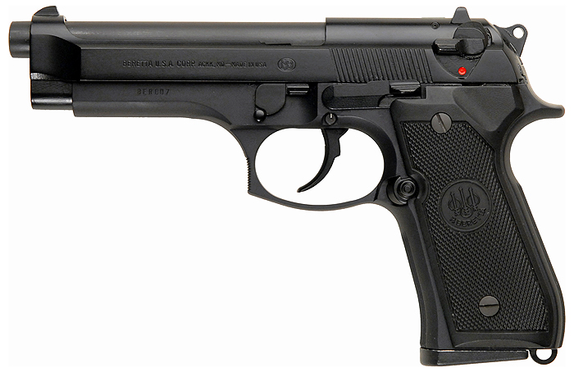
Beretta  21A Bobcat  (.25) | 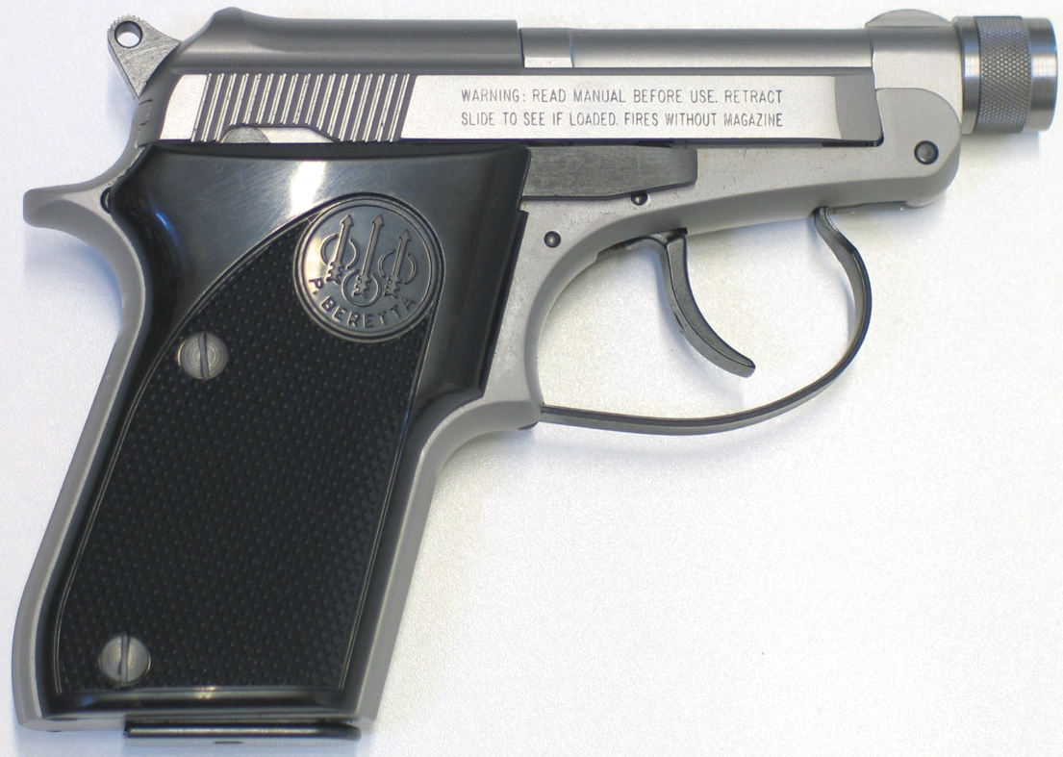
Colt  1903  (.32) | 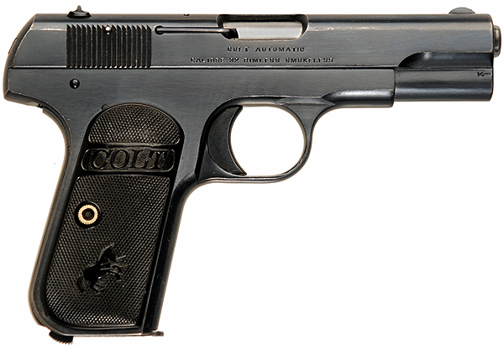
Colt  1911A1  (.45) | 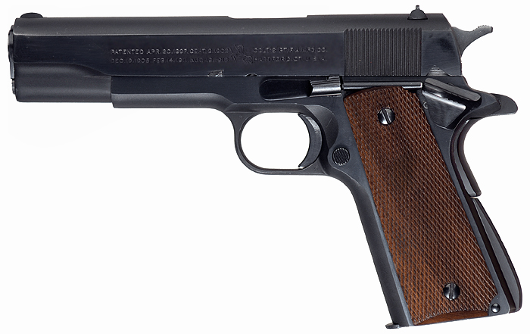
Glock  Model 17  (9mm) | 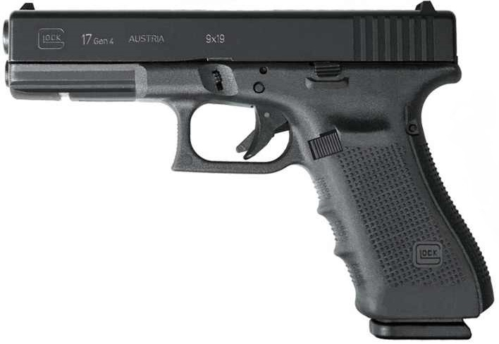
Kel-Tec  PMR-30  (.22) | 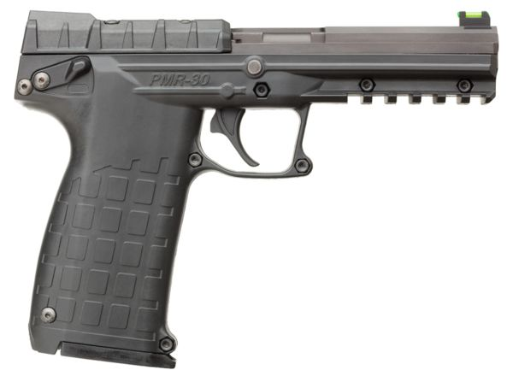
Sig Sauer  P938  (9mm) | 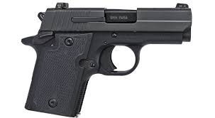
Smith & Wesson  M&P9  (9mm) | 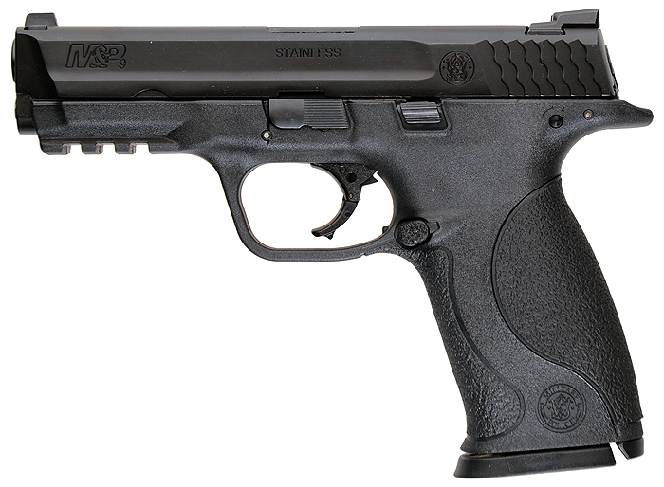
Smith & Wesson  Model 645  (.45) | 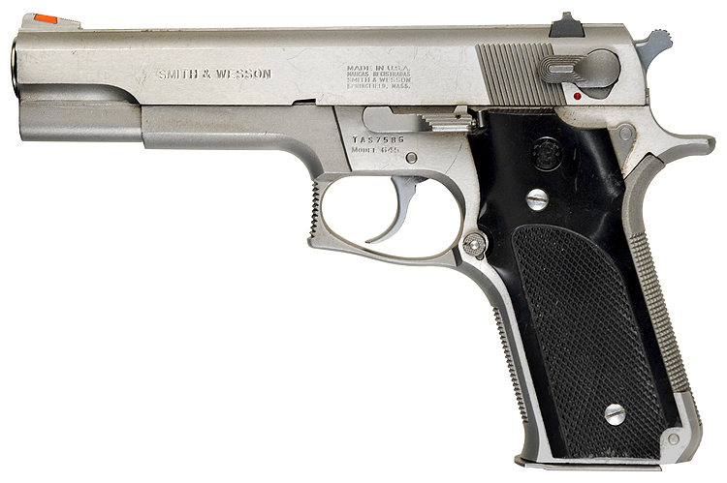
Smith & Wesson  Model 637  Airweight  (.38) | 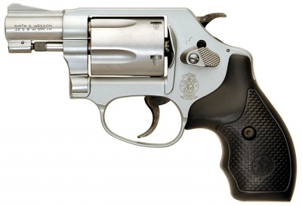
Glock  Model 19  (9mm) | 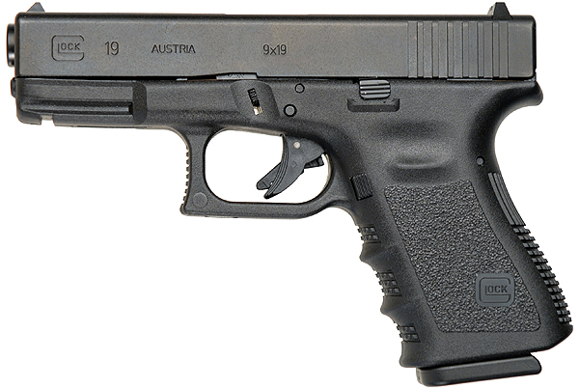
Glock  Model 43  (9mm) | 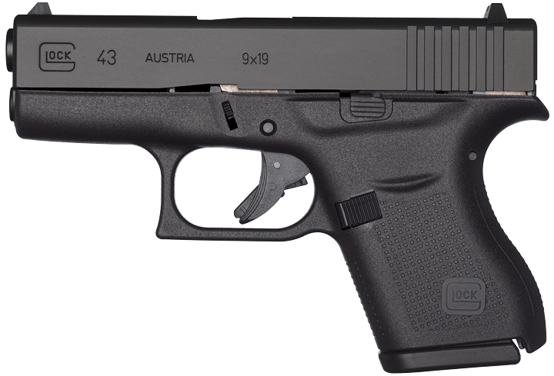
Smith & Wesson  Shield  (.40) | 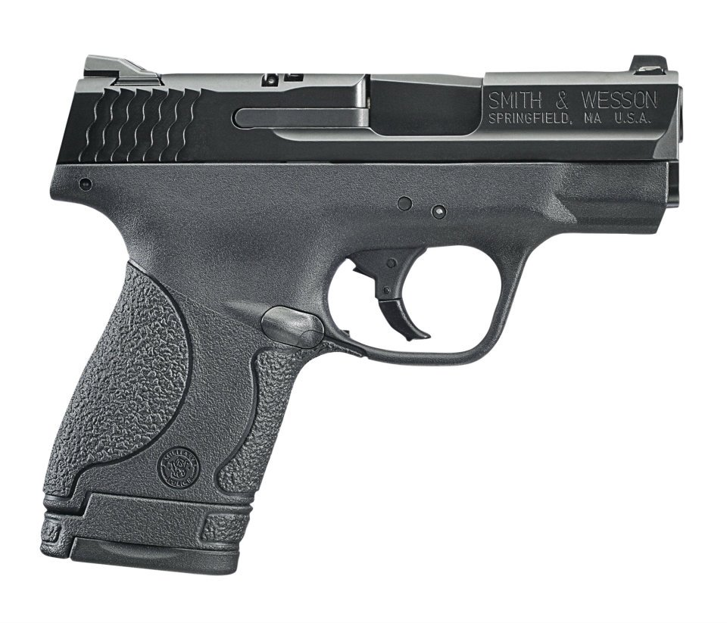
Smith & Wesson  M&P  Compact  (.40) | 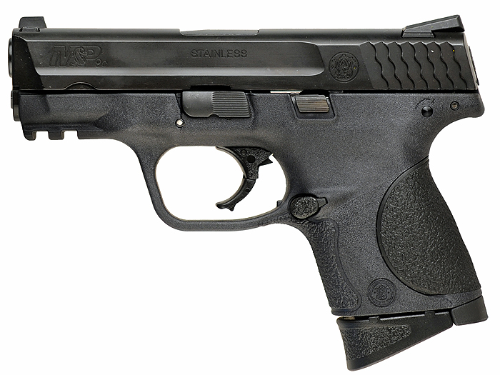
Smith & Wesson  M&P 40  (.40) | 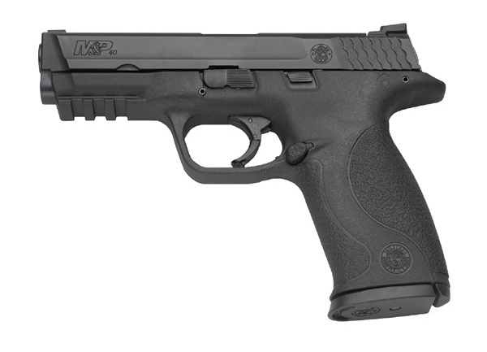
Smith & Wesson  Model 19  (.357) | 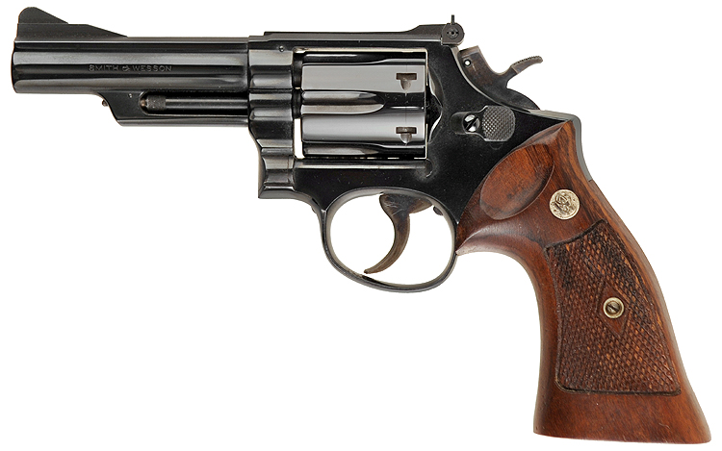
Smith & Wesson  Model 29  (.44) | 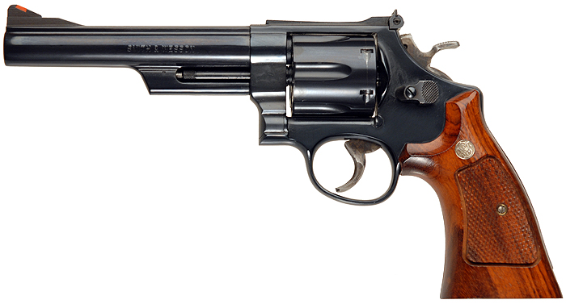
Smith & Wesson  Model 60  (.357) | 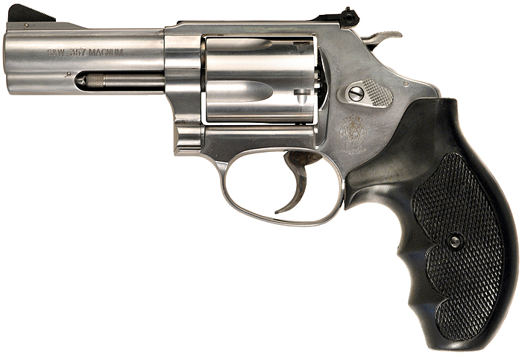
Sig Sauer  516 Pistol with forearm brace  (5.56mm) | 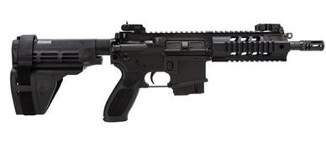
Smith & Wesson  M&P 15-22 Pistol  (.22) | 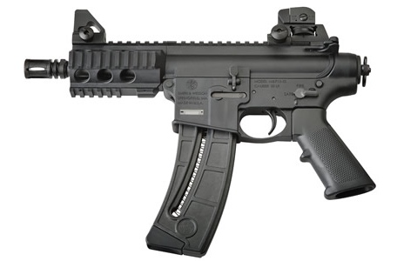
Military Armament Corp.  Model 10 (a.k.a. MAC-10)  (.45/9mm) | 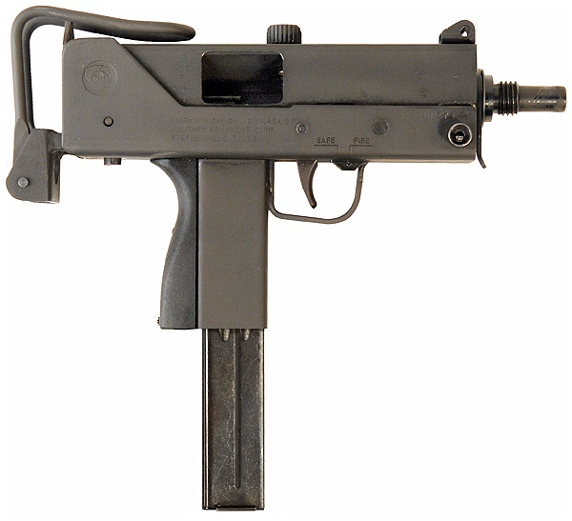
Intratec  TEC-9  (9mm) | 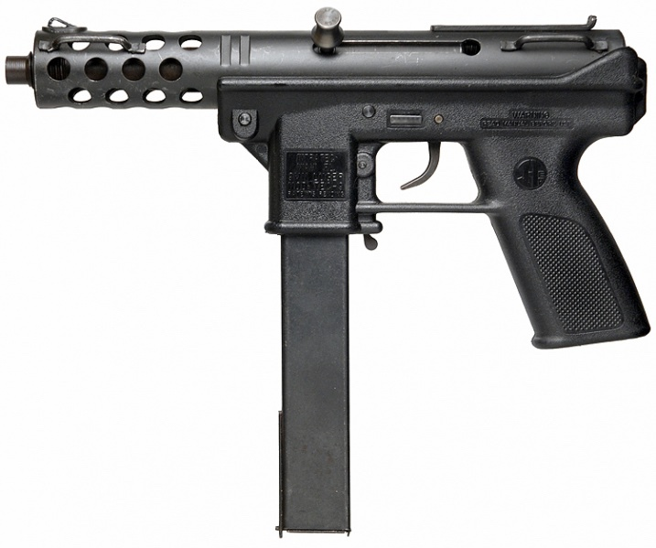

2. Shotguns

Benelli  Montefeltro  (12 gauge) | 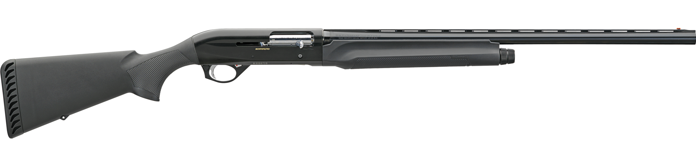
Remington  870  (12 gauge) | 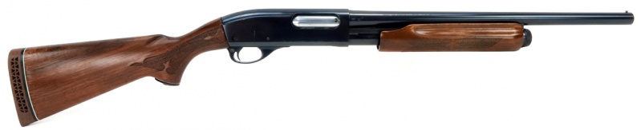
Franchi  Affinity  (12 gauge) | 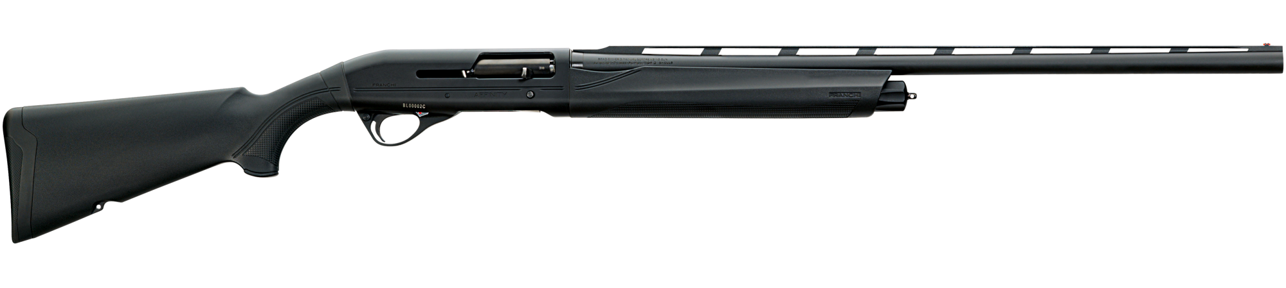
Kel-Tec  KSG  (12 gauge) | 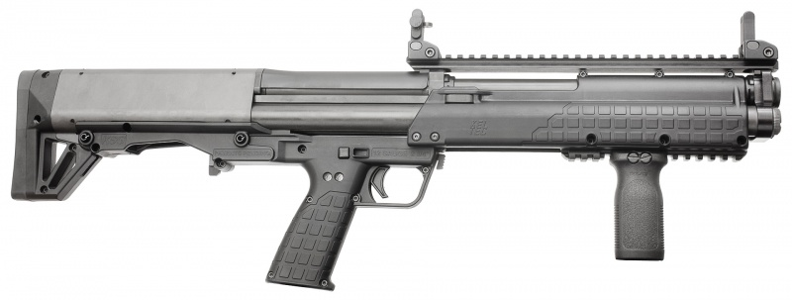
Mossberg  500  (12 gauge) | 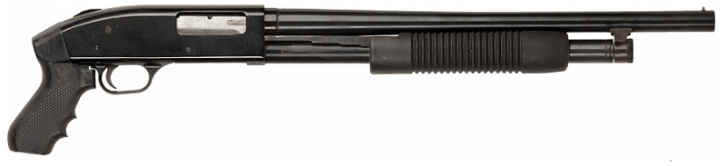
Mossberg  930  (12 gauge) | 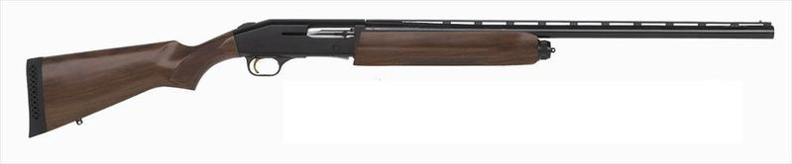

3. Bolt-Action Rifles

Ruger  10/22  (.22) | 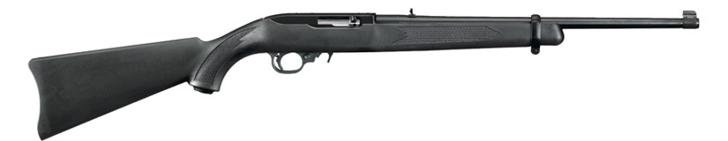
Remington  700 SPS, with telescopic sight  (.308/7.62mm) | 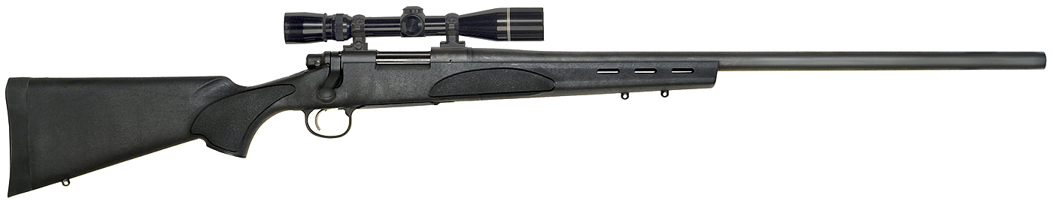
Ruger  Ruger Precision Rifle, with telescopic sight  (.308) | 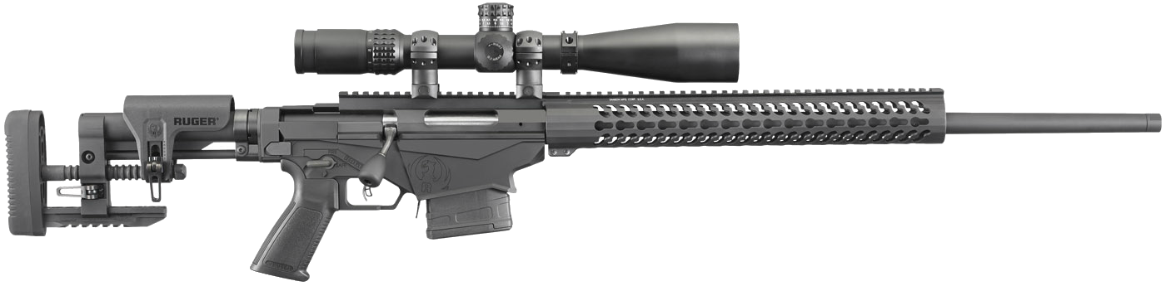

4. Semi-Automatic and Automatic Rifles

Colt  AR-15  (5.56mm) | 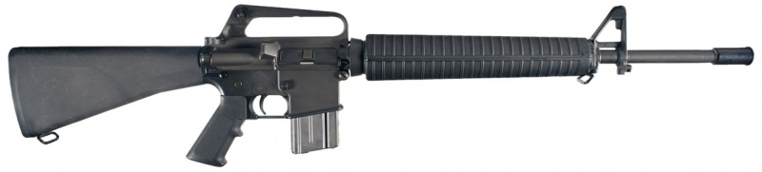
Kel-Tec  SUB-2000  (.40/9mm) | 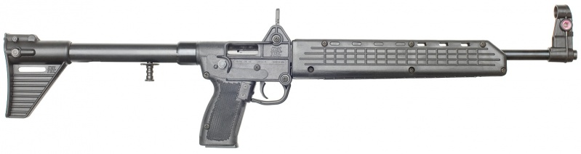
Colt  M4 Carbine  (5.56) | 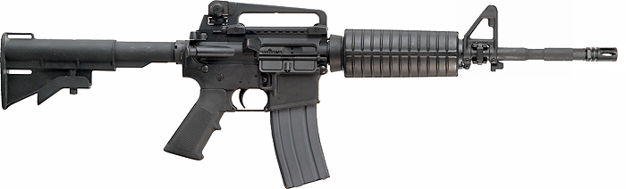
LaRue  PredatAR, with Eotech sight and foregrip  (5.56mm) | 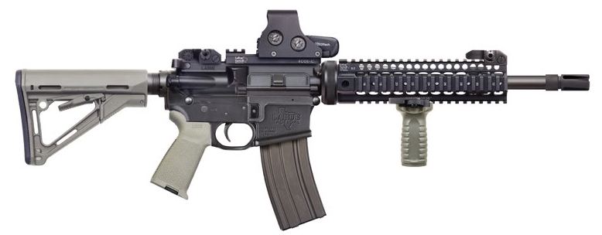
Kalashnikov  AK-47  (7.62mm) | 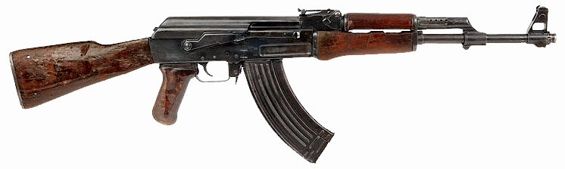
Sig Sauer  516 Carbon TS  (5.56mm) | 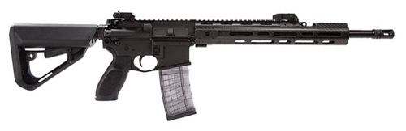
Sig Sauer  516 Patrol, with adjustable stock, telescopic sight, and bipod  (5.56mm) | 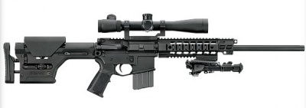
Smith & Wesson  M&P 15-22  (.22) | 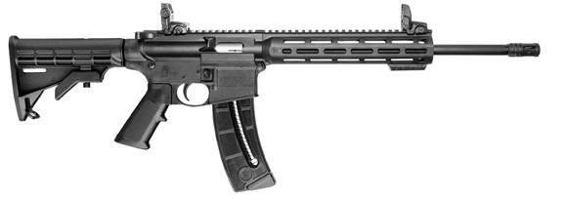
Colt  LE6920MPS-FDE, with foregrip  (5.56mm) | 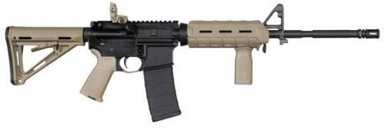
Tavor  SAR  (5.56mm) | 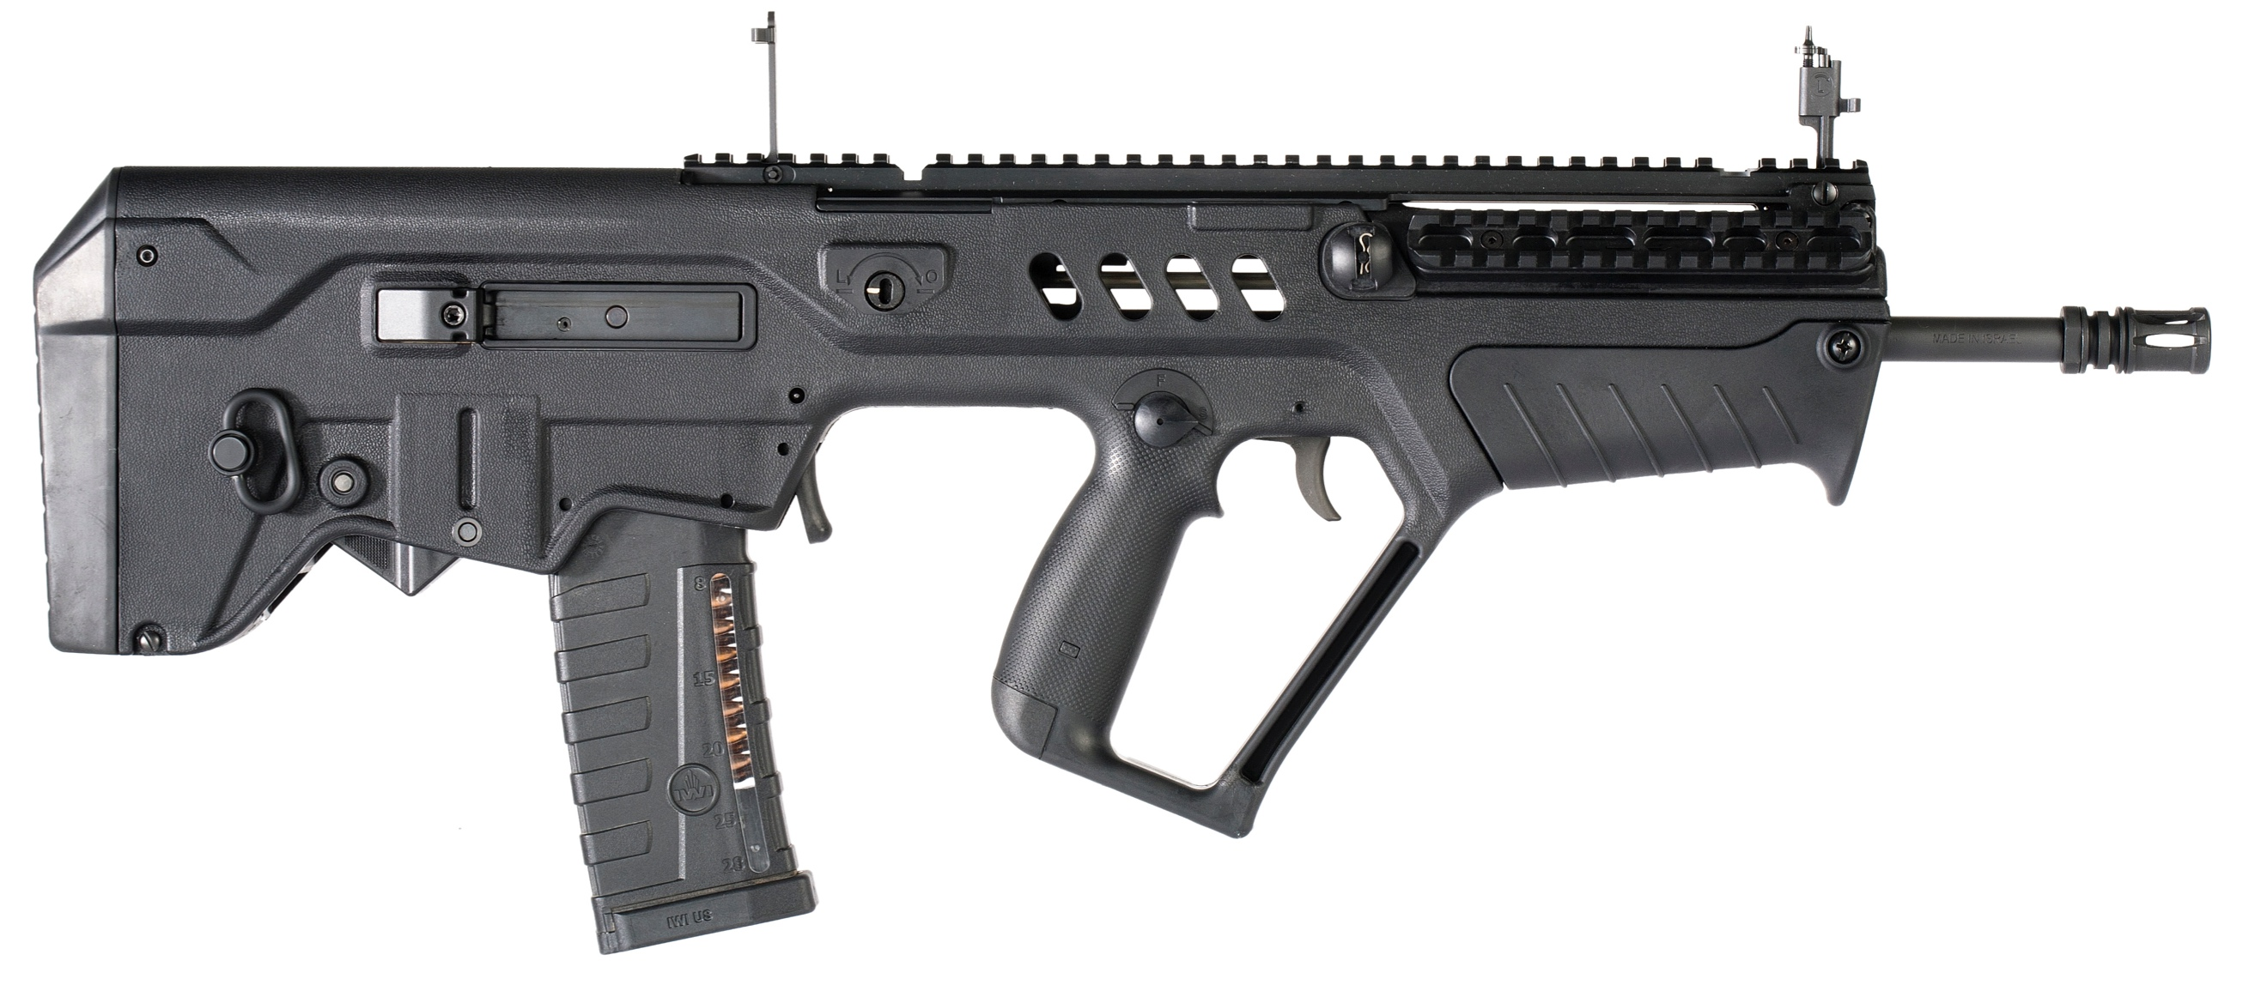
Colt  933, with sight, foregrip, and light  (5.56mm) | 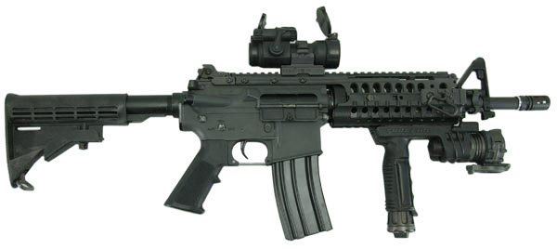

5. Magazines

Various  AK-47 Banana Clip | 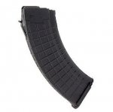
Various  AR-15 10 round magazine | 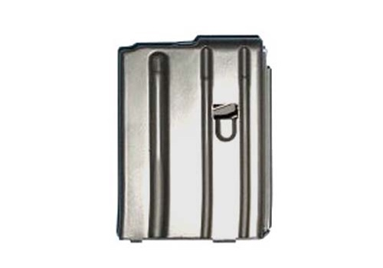
Various  AR-15 20 round magazine | 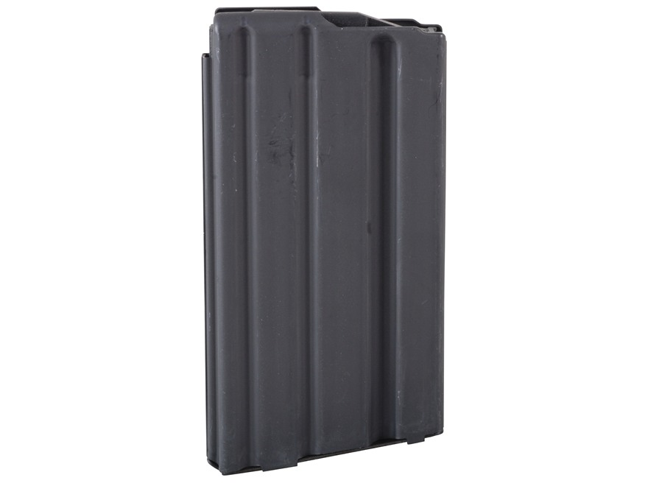
Various  AR-15 30 round magazine | 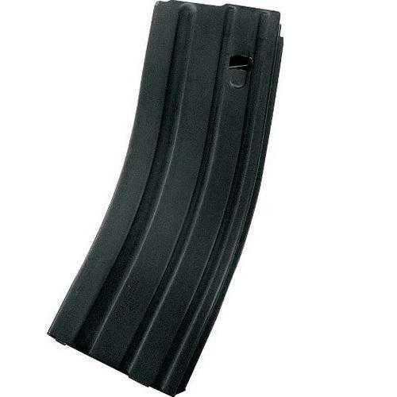
Magpul  PMAG 30 round magazine with window | 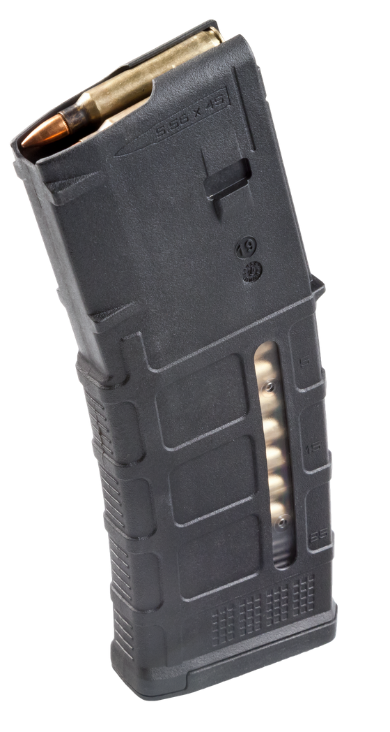
Magpul  M-60 60 round drum | 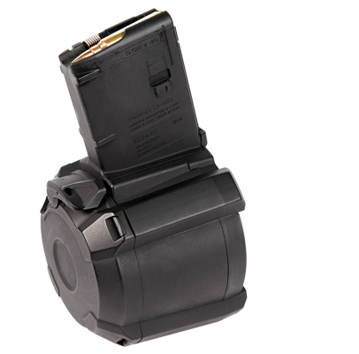
Various  Extended pistol magazine | 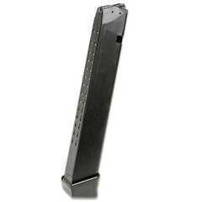

INVENTORY OF FIREARMS WORKSHEET

List the firearm(s) that you believe your intimate partner currently, or within the past six months, has owned or possessed, and the quantity, make or model, and location of the firearm(s).

 | TYPE OF FIREARM | QUANTITY | MAKE/MODEL | SERIAL NUMBER | LOCATION
1
2
3
4
5
6
7

Violence Against Women Act, 42 U.S.C. §13925 (b)(2)(2013), Family Violence Prevention Services Act, 42 U.S.C. § 10406(c)(5).

